***Auto Dry commissioning Procedure***

* Auto dry commissioning shall be performed by a technician at site with External pressure kit.
* Technician needs be well trained in 2 apps namely (1) ECM App & (1) Bluetooth App.
* Before visiting the node he needs to install the ECM app & Bluetooth app with login credentials.
* Bluetooth based Mobile App for Auto Dry Testing

Technician will open Bluetooth App and scan the Bluetooth enabled node and get paired with OMS node.

In Auto Dry Commissioning Section below sub menus will be there

1. **General Checks** - Following check will be done in Auto Mode

**General checks**

Single Button in Mobile App to fetch General checks

Controller will have one command to fetch these 5 parameters with single click

* Firmware Version: Knowing which firmware is installed
* MAC ID: Mac ID will fetch
* Battery Voltage Check: It will check if the battery is well charged
* Solar voltage: Solar Voltage Check
* Door Status: Open/ Close Status
* LORA communication check: it will check if OMS Node is connected the Server or not

Controller will give one command at uplink and after getting downlink- confirmation will be sent by controller that Communication is OK/Not.

1. **Pressure Transmitter Value check**:

* Technician will connect external pressure kit with Pressure Gauge to OMS with 2.5 bar standard value, Using pressure kit default 2.5 bar water pressure will be created in hydraulic tubing
* Then Technician should press single command from mobile app to check all PT Values
* The Kit will be designed in such way that all the PTs will receive water .

**Check PT Values**

On clicking of Check PT Values App will send Get AI1, AI2,…..AI8 command sent to all valves one by one through mobile app and getting all PT values, If Value is within ±10% of 2.5 bar it will show PT OK otherwise it will be show Faulty.

* Technician must get all Pressure values in bar
* Filter Inlet PT : _____bar OK
* Filter Outlet PT: ______bar OK
* OUT PT1 : ______bar FAULTY
* OUT PT2: ______bar OK
* OUT PT3: ______bar OK
* OUT PT4: ______bar FAULTY
* OUT PT5: ______bar OK
* OUT PT6: ______bar OK

1. **Solenoid check**:

Separate 6 commands given by mobile app to check Solenoid –Open/Close operation

**SOV1 Open/Close**

SOV1 OK

**SOV2 Open/Close**

SOV2 OK

SOV3 FAULTY

**SOV3 Open/Close**

**SOV4 Open/Close**

SOV4 OK

**SOV5 Open/Close**

SOV5 FAULTY

**SOV6 Open/Close**

SOV6 OK

Operator has to check sound/check is solenoid opening/closing/ water getting from that solenoid, operator has to decide solenoid is OK/Faulty/ Need to repair/replace that faulty

Or again he can give Open/close command to that Solenoid

1. **Position Sensor check**

* Technician should press single command from mobile app to check all 6 Position sensors values

**Check Position Values**

On click of Check Position Values – Get PFCMD6TYPE PIN NO command sent to all valves one by one through mobile app and getting all mill ampere values, If Value is within 4 to 20 mA its Showing POS OK otherwise showing Faulty.

Technician must get all Position values in mA

* POSITION SENSOR1 : ______mA FAULTY
* POSITION SENSOR2: ______mA OK
* POSITION SENSOR3: ______mA OK
* POSITION SENSOR4: ______mA FAULTY
* POSITION SENSOR5: ______mA OK
* POSITION SENSOR6: ______mA OK

If any of the above tests fail the Technician will repair or replace the sensors or devices and re-perform the test.

1. Submit Report

Once all the tests are done the technician will press Submit button which will save result in a pdf file the file in his phone.

**Submit**

It Ask to save that PDF File, Technician can rename that file with node number or mac id. After that he needs to upload this file in ECM Mobile App.

* ECM App :For updating results in ECM application

ECM Mobile App:

* After performing Auto Dry Test, Technician needs to open the ECM app and select the particular node of that project.
* Go in ECM option & go to Auto Dry commissioning Menu & gets below Steps,

1. Installation & Visual Checks – It contains the necessary checklist to be performed, technician should physically verify each and every point and then tick the points and after that press confirm button to start further Auto dry tests.

* OMS Enclosure cabinet check
* Visual checking of all installed accessories.
* Check the Connection of Antenna
* Check the connection of Solar Panel
* Check all instruments cable connections
* Check the connections of Hydraulic tubing

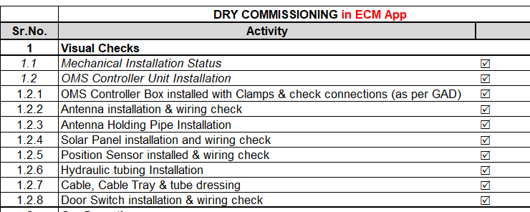

1. Auto Dry test report upload
   * + He will get option to upload that PDF file there
2. Images Upload

He can click or select from gallery and upload necessary images and submit that Auto dry commissioning is done

* After submitting Auto dry commissioning data from App the results will be uploaded to ECM Web Application and WebSCADA .

ECM Webpage :

* + On Web ECM Auto dry commission status will be reflected along with report and images to be monitored by the Manager

Web SCADA:

* + After Dry Commissioning WebSCADA will monitor the node for 7 days checking its basic data (to be finalized) again and will report that the node is ready for Wet Commissioning .
  + Following parameters will be monitored for 7 days
  + Battery,
  + Solar Voltage pattern,
  + Door Open status,
  + Missed data packet /Communication status,

***Auto Wet commissioning procedure***

Wet Commissioning can be performed with or without technician at site from Web SCADA/Web ECM

* Once Dry commissioning is performed and 7 day monitoring done i.e. node is ready for Wet commissioning As soon as the water is available in pipe line, user will be able to start Wet commissioning.
* First he has to give set parameters like Sustaining Pressure, Reducing Pressure, Flow, Valve Open-Close timing etc. and then Give Start Auto Wet commissioning Command to node .
* Wet Commissioning will be set for a default schedule of 6 hours in Flow Control Mode
* Status will be displaying on node that it is in Auto Wet Commissioning state
* Controller will perform predefined test program saved in it with Set Parametrs from Web SCADA for wet commissioning. And After test completed after 6 hrs one data Packet will be sent by Controller that Auto Wet Test done and it has 5 mins interval values for 6 hours test cycle performed.
* SCADA have define page to record and monitor these Auto Wet test values for operator to monitor
* These values and status of Auto commissioning also record in ECM App and ECM Web.